

UAAR Emergency Numbers and General Information
Table 1 Emergency Phone Numbers
Emergency Phone Numbers
EMERGENCY | 911
UC Irvine Police Dispatch | 949-824-5223
City of Irvine Police (non-emergency number) | 949-724-7000 (for non-emergencies)

Table 2 UCI Emergency Management Information - Websites
UCI Emergency Management Information - Websites
UCI Emergency Management
UCI Campus Evacuation Information (Know Your Zone)
UCI Campus Emergency Response Procedures
UCI Campus Assembly Areas

Table 3Emergency Coordination Information by Location
Emergency Coordination Information by Location
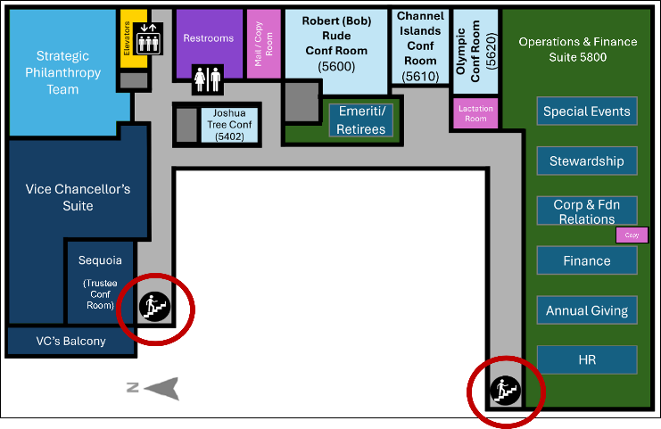
Continuing Education 1 (CE1), 5th Floor
- Building 8 on campus maps
- Street Address: 510 East Peltason Drive
- Emergency exits (stairs) are located at the “inside” corners of the building, next to the Vice Chancellor’s suite and cubicle A10 in suite 5800. Evacuation information is posted at each exit.
- Evacuation Assembly Areas: Parking Lot 17A and the parking lot adjacent to Student Health II (Building 6 on campus maps)
- UCI Evacuation Zone: C2 (See last page for additional information)
Newkirk Alumni Center
- 450 Newkirk Alumni Center
- Evacuation Assembly: Parking Lot 14 (next to University Drive)
- UCI Evacuation Zone: A20
Health Advancement in Irvine
- 856 Health Sciences Road, Suite 5838
- Evacuation Assembly: Circular Driveway in front of Gavin Herbert Eye Institute (Building 850 on campus maps), and parking lots 83 and 83D
- UCI Evacuation Zone: B8
Health Advancement in Orange
- 3800 W Chapman Avenue, Suite 3300
- Location-specific evacuation plan, with drills conducted annually
- Orange County and the City of Orange are responsible for emergencies at this location and authorities will coordinate with UCI as needed
- Evacuation Information: Follow directions on signs located next to each stairwell and elevator door

Table 4Emergency Communications
Emergency Communications
If an emergency happens that requires an evacuation, campus personnel will be notified via the following methods:
- zotALERT – an emergency alert system that uses cell phone text messaging to quickly notify the UCI community with safety information. You can sign up to receive these emergency message by visiting the UCI OIT website.
- UCI Emergency Updates Page – a website that will provide you the most up-to-date information during an emergency and can be access via Emergency Updates | UCI.
- Social Media – updates regarding the emergency will be posted via Twitter (@ucirvine) and the Facebook (University of California, Irvine - Home | Facebook)
- AlertOC is a mass notification system designed to keep Orange County, California residents and businesses informed of emergencies that may require immediate lifesaving actions. By registering with AlertOC, time-sensitive voice messages from the County or City in which you live or work may be sent to your home, cell, or business phone. Text messages may also be sent to cell phones. AlertOC can send out messages to email accounts and TTY devices as well. AlertOC is run by the County of Orange in collaboration with local cities. Sign up here: http://www.alertoc.org/
- Additional methods for receiving information during an emergency are 1-800-IRV-NEWS, our Hotline, AM 1690 radio, news-boards, and marquees.

Table 5Tips from UC Irvine Department of Finance and Administration
Tips from UC Irvine Department of Finance and Administration
Know UCI’s Emergency Response Procedures
- Evacuation Procedures: Familiarize yourself with the evacuation routes and assembly areas for the buildings you frequent.
- Shelter-in-Place Protocols: Know when and how to shelter in place during incidents like hazardous material spills or air quality emergencies.
- Communication: Make sure your contact information is up to date to receive zotALERTs, UCI’s emergency notification system.

Review detailed procedures and resources at em.uci.edu.

Your Responsibility for Personal Preparedness.
Preparedness is a shared responsibility. Here are some steps you can take to ensure you’re ready for any emergency:
- Build an Emergency Kit: Keep essential items like water, non-perishable food, medications, and personal documents ready in case you need to evacuate.
- Create a Personal Evacuation Plan: Identify multiple routes and know where you would go if you had to leave campus quickly.
- Stay Informed: Bookmark em.uci.edu and review the UCI Emergency Management emergency procedures.

Additional CE1 5th Floor information:
Emergency Exits, Sample Evacuation Plan posted next to exits, evacuation assembly areas
