

UAAR - CE1 5th Floor FAQs and Shared Spaces Guide

ADDRESSES
Our physical address is:
510 East Peltason Dr., Suite 5000
Irvine, CA 92697-5600

Gifts should be mailed to:
UC Irvine Foundation
[SCHOOL/UNIT/DEPARTMENT/ETC.]
101 Aldrich Hall
Irvine, CA 92697-5600

Incoming mail will be delivered to the mail room and will be sorted for distribution on a regular schedule
Outgoing mail and packages can be dropped off in the mail bag located on the 2nd floor behind the reception desk. Please make sure to drop it off in the mail bag marked ZOT 5600.

Deliveries:
- 2nd Floor Lobby Desk is staffed by DCE student staff from 8AM - 5PM and will accept deliveries
- Lobby Desk staff will announce deliveries on Teams by tagging the recipient
- The DCE Building Management team will deliver to our mail room for the recipient to pick up

ZotCode:
We are consolidating the UAAR ZotCodes 5600 and 5601 to 5600 only

Incoming Mail and Return Addresses
Always use the appropriate ZotCode+2 for your area, if listed below

Table 1 ZotCode +2 for UAAR Areas
General UAAR and VC’s Office | 5600 |  | Annual Giving | 5600-07
UCI Foundation Board | 5600-01 |  | Finance & Administration | 5600-08
Corporate & Foundation Relations | 5600-02 |  | Special Events & Protocol | 5600-09
Gift Administration & Gift Services | 5600-03 |  | Planned Giving | 5600-10
Donor Relations | 5600-04 |  | Advancement Communications | 5600-11
Chancellor’s Club | 5600-05 |  | Scholarships | 5600-12
Parents Program | 5600-06

BUILDING ACCESS
- A key card is required to activate the 5th floor button in the elevator and for after-hours access to the building
- A key card is required to access the 4th floor Staff Lounge (both the floor and the lounge itself (see “SHARED SPACES” below)
- After hours, a key card is needed to activate the 3rd floor “After Hours Exit” button in the elevator

DIRECTIONS
- Located on the 5th floor of Continuing Education 1 (CE1)
- Building 8 on campus maps, interactive map available at map.uci.edu
- See the last page for full directions and map

CONFERENCE ROOMS and SHARED SPACES

Conference Rooms
There are four (4) conference rooms available, all are “Zoom-ready” and are available to reserve through Outlook using the below names.
- Joshua Tree (5402), capacity 8 people “DCE – 5402 Joshua Tree Conference Room”
- Bob Rude (5600), capacity 20 people “DCE – 5600 Bob Rude Conference Room”
- Channel Islands (5610), capacity 12 people “DCE – 5610 Channel Islands Conference Room”
- Olympic (5620), capacity 14 people “DCE – 5620 Olympic Conference Room”
Note: The Trustee Conference Room (Sequoia) is booked through the Vice Chancellor’s
executive assistant.
Lactation Room
A lactation room (5624) is available on a drop-in basis
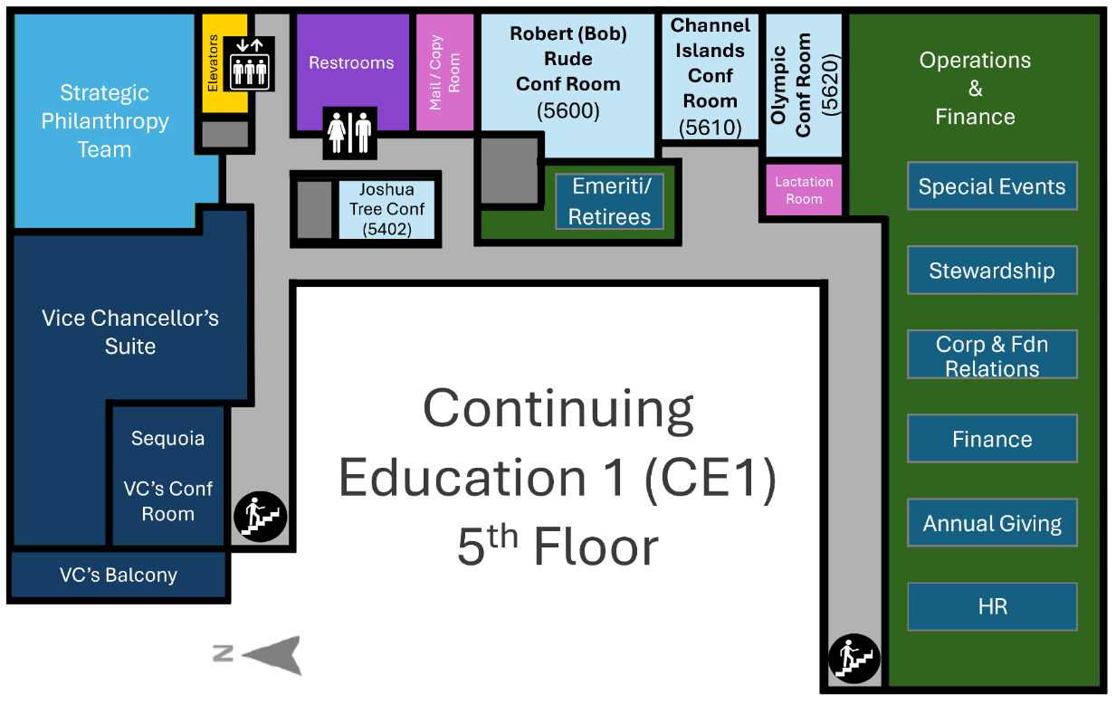
Operations & Finance
Suite 5800
Copy
(Trustee Conf Room)

SHARED SPACES, continued

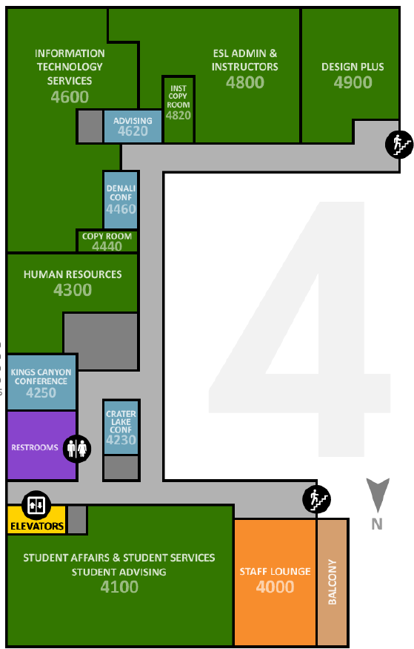
Staff Lounge (Break/Lunchroom)
STAFF LOUNGE
4000
4th floor, Suite 4000; available to all CE1 building staff
(key card required)
- Two refrigerators, two microwaves, coffee maker, ice maker, toaster oven
- Inside and balcony seating

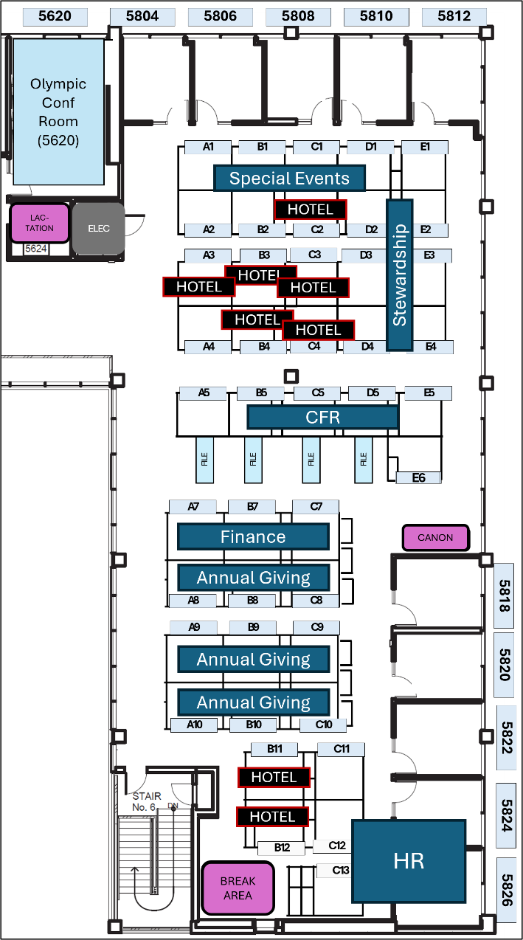
UAAR Hoteling Workspaces
- There are eight (8) hoteling cubicles located in the 5800 Suite C2, A3, B3, C3, B4, C4, B11, B12
- These are available on a first-come basis
- All personal / work-specific items must be removed by the end of each day’s use of the space

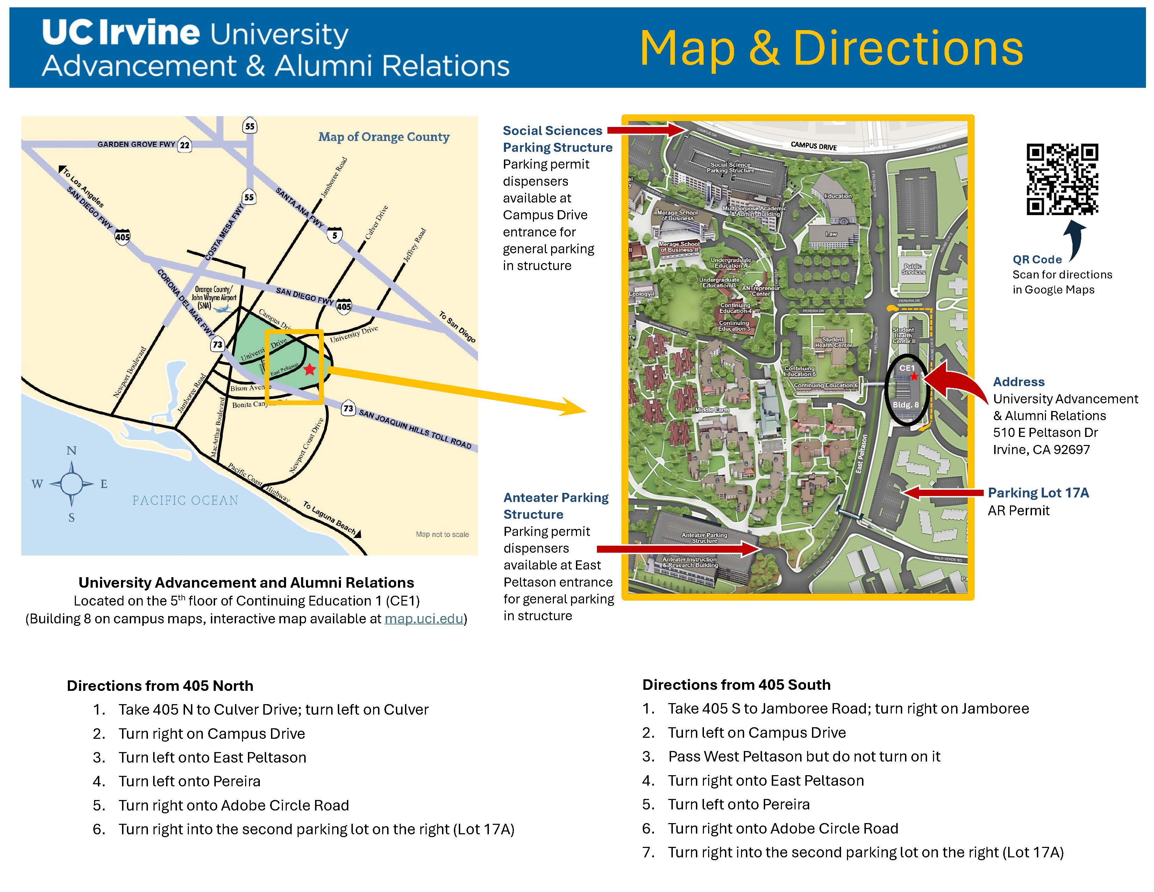
PARKING
Lot 17A is the assigned lot for CE1
- Requires an AR permit
- Permit options:
- Monthly AR Permit
- Day Use AR Permit
- Sustainable Transportation (ST) Incentive Permit (see below)

Anteater Parking Structure and Social Sciences Parking Structure
- Within walking distance
(~15 minutes)
- Can use monthly or
day use AR, C (General), or ST Incentive permits

Monthly Permits
- Purchase through UCI’s myCommute portal

Sustainable Transportation
- For those with hybrid or primarily remote schedules, the Sustainable Transportation (ST) program may be more cost-effective than purchasing monthly or day use permits
- Sustainable Transportation membership can be requested through the myCommute portal, using the “Become an ST Member” button
- ST members earn 5 ST Incentive permits per month
- ST Incentive permits are valid in any unmarked or AR reserved parking stall, except for Lot 80, Service, X, P, disabled stalls without also displaying a disabled placard, pay by space, or metered stalls
- Incentive permits are earned monthly and are issued every 30 days. Any unused ST incentive permits are rolled over into the next month.
- Permit(s) not used by the end of each fiscal year (June 30th) do not carry over

